Marmara University
Engineering Faculty
Electrical and Electronics Engineering
EE4077: Fundamentals of Machine Learning

Midterm Exam (Spring, 2023)
- In this problem, you will see how to learn a binary Naive Bayes classifier. Consider the dataset below. You are looking to buy a car; the label is 1 if you are interested in the car and 0 if you aren’t. There are three features: whether the car is red (your favorite color), whether the car is affordable, and whether the car is fuel-efficient.

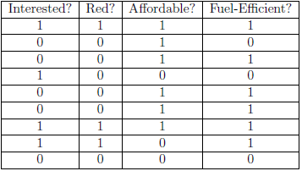
- [5 pts] How many parameters do we need to learn?
- [5 pts] Estimate the parameters via MLE..
- [5 pts] If I see a car that is red, not affordable, and fuel-efficient, would the classifier predict that I would be interested in it?
- [5 pts.] Is there a problem with this classifier based on your calculations for the previous question? If so, how can we fix it?

- In this problem, you will see how to learn a binary logistic regression classifier. Consider the dataset below, where $Y$ is the class label and $X$s are attributes

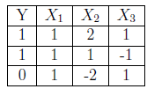
- [5 pts] What is classification error $J(θ)$ if the initial weight vector for the attributes is equal to $θ={\left[-2,2,1\right]}^{T}$
- [5 pts] Calculate $\frac{∂J^{\left(1\right)}(θ_{1})}{θ_{1}}$, $\frac{∂J^{\left(1\right)}(θ_{2})}{θ_{2}}$, $\frac{∂J^{\left(1\right)}(θ_{3})}{θ_{3}}$ for the first training sample (first row). Note that $σ(3)≈0.95$
- [5 pts] Calculate $\frac{∂J^{\left(1\right)}(θ_{1})}{θ_{1}}$, $\frac{∂J^{\left(1\right)}(θ_{2})}{θ_{2}}$, $\frac{∂J^{\left(1\right)}(θ_{3})}{θ_{3}}$ for the second training sample (first row). Note that $σ(-1)≈0.25$
- [5 pts.] Assuming we are doing stochastic gradient descent with a learning rate of 1.0, what are the updated parameters $θ$ if we update $θ$ using the second training example?
- [5 pts] What is the new $J(θ)$ after doing the above update? Should it decrease or increase?
- [5 pts] Given a test example where ($X_{1} = 1,X_{2} = 3,X_{3} = 4$), what will the classifier output following this update?

- In this problem, you will see how to learn a decision tree. Consider the following data set with two features $X_{1},X_{2},$ and label $Y$, where ‘−’ marks represent $Y = 0$ and ‘+’ marks represent $Y = 1$.

- [6 pts] What is the entropy of Y in bits?
- [6 pts] What is the mutual information if we are splitting on $X_{2}< 2.5$?
(c) [6 pts] Using error rate as the splitting criteria, what is the best choice for the first binary split?
(d) [6 pts] If the tree only has one binary split (i.e., a decision stump), what would be the lowest training error rate we can get?
(e) [6 pts] Is it possible to have a decision tree with zero training error for this dataset? Assume only binary splits and attributes selected with replacement.
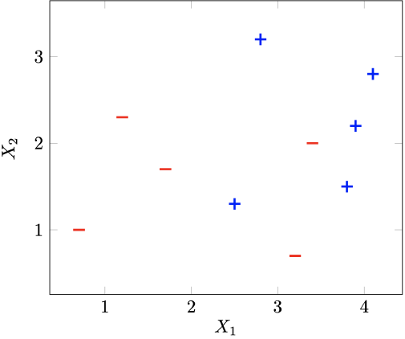

- In this problem, we will consider the effect of training dataset size $N$ on a logistic regression classifier with d features. The classifier is trained by optimizing the conditional log-likelihood. The optimization procedure stops if the estimated parameters perfectly classify the training data or they converge. The following plot shows the general trends in training and testing error as we increase the sample size $N = |S|$
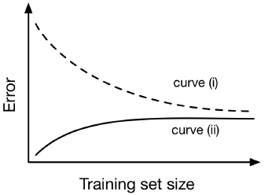
- [5 pts] Which curve represents the training error? Provide 1-2 sentences of justification.
- [5 pts] In one word, what does the gap between the two curves represent?

- (a) [5 pts] What are the four main tasks in machine learning?
(b) [5 pts] What is the corresponding machine learning task if want to estimate the price of a house based on a dataset. Indicate the underlined machine learning task if want to decide if an email is spam or not based on a dataset.

